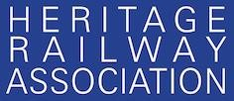 | 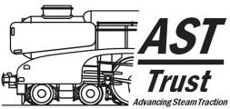
Return to coal@bvrw.co.uk
Fuel Trial Record
Fuel being tested
Test Railway
Date of Test
Locomotive type, Name and Number
Description of train consist
Driver
Fireman
Test Observer
Observations and footplate crew comments
Locomotive preparation
Lighting up including
- Ease of ignition
- Time to raise steam
- Smoke generation
Operation
Train haulage including
- Under load
- Coasting
- Run round
- Smoke colour and odour
- Rapidity of ignition of fresh coal
- Freedom of steaming
- Evidence of clinker
- Evidence of unburnt fuel loss/spark throwing
- Fire shape used
e.g. saucer, level, wedge, haycock etc
- Is locomotive fitted with a brickarch?
- Was secondary air used?

Disposal
Smokebox
- Quantity of char
- Evidence of blocked tubes
- Unusual deposits on internal surfaces
Firebox
- Evidence of clinker
- Evidence of birds nests
- Unusual deposits on internal
surfaces
Ashpan
- Quantity of ash
- Evidence of unburnt fuel particles
Qualitative scoring of fuel performance by footplate crew
Freedom of steaming
1=Poor 5= good
Coal ignition time 1=slow
5=fast
Smoke colour 1=black
5=clear
Smoke odour
1=unacceptable 5= low
Unburnt fuel loss/spark throwing 1=high 5=low
Clinker and birds nest
formation 1=high 5=low
Quantity of fuel used
1=high 5=low
Quantity of char in smokebox 1=high 5=low
Quantity of ash in ashpan
1=high 5=low
Other Observations/Comments

