Britain’s Great Little Railways



|  |  |
| --- | --- |
| **Newsletter 82** | **June 2021** |

**Re-Opened (Again)**

Most of our railways re-opened on April 12th when the Government lockdown regulations changed. The BGLR website has kept potential visitors up to date with the status of each of our railways. It would seem that all of our railways have weathered the three lockdowns, somehow and are up and running again with many of them having carried out extensive refurbishments/improvements during the extensive lockdown periods.

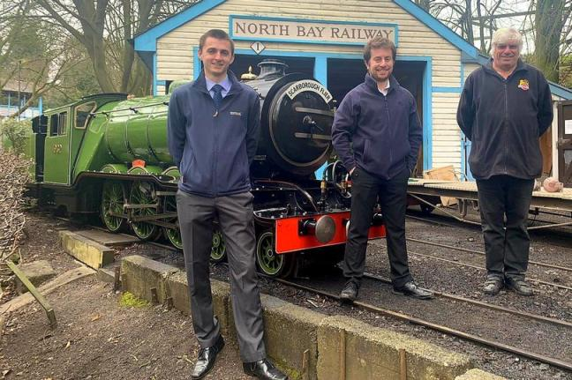**BGLR News**

**North Bay Railway** - Article and photo from Yorkshire Live

**John Kerr (left) Peter Bryant (centre) David Humphreys (right)**

Scarborough’s historic North Bay Railway is under new management following the retirement of its previous owner.

The railway, one of Scarborough’**s** top attractions, was bought from the council in 2007 by David Humphreys, who added new rolling stock, station buildings, and lakeside attractions.

It is now in the hands of John Kerr and Peter Bryant, who have run the Cleethorpes Coast Light Railway in North East Lincolnshire since 2014.

Mr Kerr said: “The railway in Scarborough is an extremely important asset to the town and wider region.

“Before his retirement, David has done a fantastic job of revitalising this much loved attraction and we are looking forward to working with his dedicated team to further this.

“We can’t wait to take the railway to its centenary and beyond.”

The 90-year-old narrow-gauge system, first opened in 1932, runs for three-quarters of a mile from Peasholm Park Station to Scalby Mills, with views over North Bay.

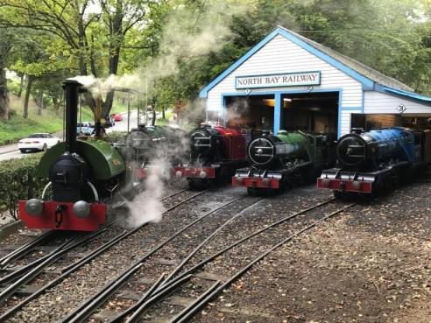It currently operates a steam train, as well as four diesel engines – Neptune, Triton, Poseidon and Robin Hood – which have been in service since the 1930s.

The railway and other attractions re-opened on April 12th

David Humphreys continues to operate NBR Engineering Services which specialises in engineering for historic steam traction. Their website has more information http://www.nbres.co.uk/

*Photo by Jamie Dunn*

**October General Meeting**

No plans are in place for an October General Meeting and are unlikely to begin until the final phase of the Governments return to normal plan is announced in June. The Chairman and the Directors will then make the decision whether to hold the meeting in October.

**HRA, LEGISLATION, & SAFETY REPORT**

*BGLR is a corporate member of the Heritage Railway Association. Members can read HRA “members only” publications on www.hra.uk.com/ by entering the username* bglr *and the password* kcnsy37

Nothing specific to report at this time but a lot is happening behind the scenes with the CEO of HRA, Stephen Oates seemingly unhappy with our "very low subscription rate". More to come as this develops.

**NEWS FROM OUR MEMBERS**

**Barnards Railway**

Barnards Railway was shut for the whole of 2020 but has now re-opened. Below is there account of the work carried out during the shutdown.

Despite the current difficulties we have managed to not only do maintenance jobs but further develop the railway here at Barnards.

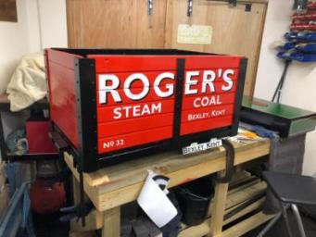All our carriages have been repainted and some rolling stock have been refurbed, in this case in memory of one of our volunteers, Roger Humphreys and some experimental rolling stock such as the hydraulic gravel distributor put to good use.

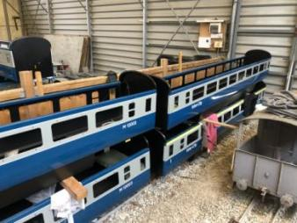

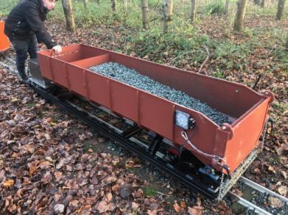

We have put a spur line alongside our gravel store and an additional spur has been put in at Sitooterie Halt to hold a spare engine if a double header is required to reach Angel Green Station.

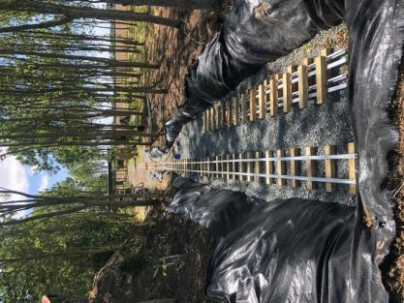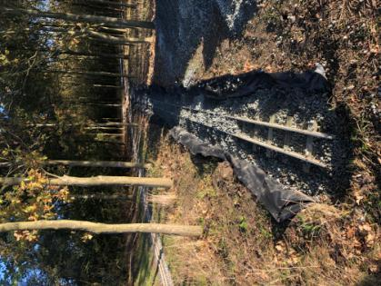

To enable our EMU branch line to run to a second Sitooterie Halt we are triple tracking at our Belvedere Station. The EMU side of the Belvedere Station has also been completed as has our second EMU unit shown here and built in our own workshops.

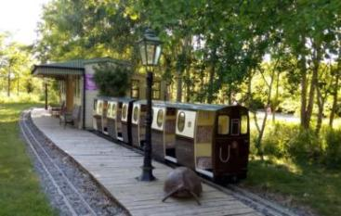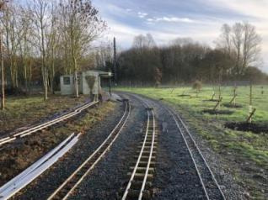

The EMU Branch line will run from the other end of the platform. The EMU line will then run across the end of the runway. The return line from Sitooterie Halt has already been aligned.

The track bed for the EMU Branch line has already been prepared and inspected by my Grand Daughter Talia-May and extended towards the lake in front of the Sitooterie.

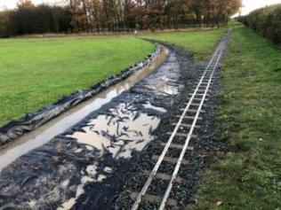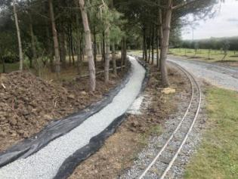

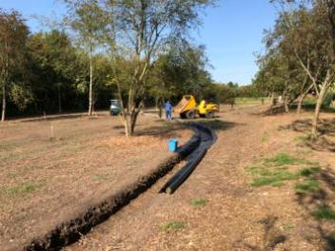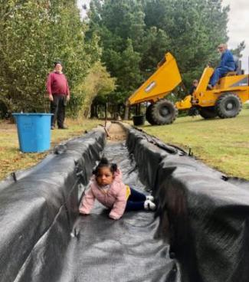

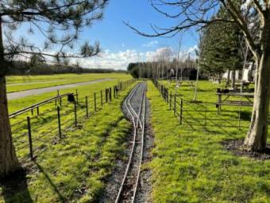

At the Burtonshaw end of the track a separate EMU station nears completion.

To accommodate the EMU units a new spur now goes out from our Burtonshaw turntable. To improve the EMU units egress from our shed the line has been relayed and re-pointed.

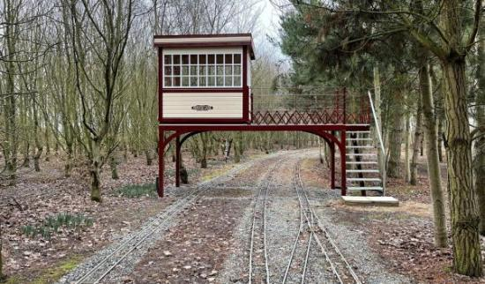

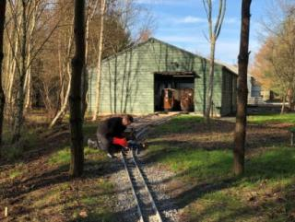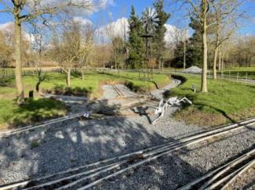

In honour of our founding member, Mike Pardoe, we have installed a new Signal Box at Pardoe Lane master of all it surveys and inspired by one of countries listed signal boxes at Hexham. We are also a fair way through installing a signalling system.

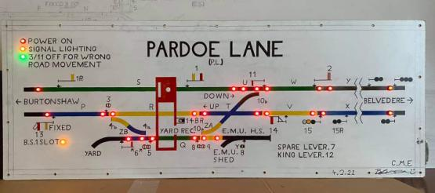

We didn’t open at all in 2020 but are planning, all being well to operate a limited season this year and hopefully to run our Winter Light Trains and Santa Specials in November and December. *Bernard Holmes*

**Thompson Park Railway**

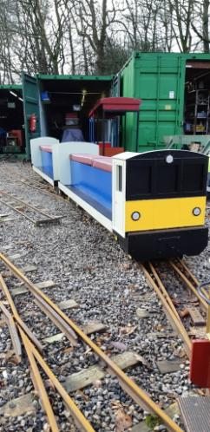We opened to the public on Sunday 18th April again using last year's covid safety policy. Operating a one way system and sticking to cash only payments. All stock was cleaned prior to running but not after each trip. Hand sanitizers were provided at the entrance and exit to the station.

What a great turnout we had over 400 rides on the first Sunday and twice we had more than 500 rides during the first few Sundays. We had to cancel our Mayday running because of the heavy rain which persisted  over Burnley all day. When the next change came in the covid 19 rules we decided to start reopening again on Saturdays .

We have decided to give our free lollipops a miss this year but hopefully we will have them back in 2022. After all we known as the lollipop line. One of our popular features was to offer birthday parties but at this moment in time we have not yet made a decision when to start offering these again.

Work has been continuing on our railcar and we hope to have this back in service soon. We have also taken possession of a new steam locomotive which has been purchased by one of our members. This belonged  to Fred  Berry a founder member of the society and our president for several years . Fred sadly passed away in March 2020 a victim of covid. We are looking forward to 'Ivy' running again around the park. The picture is of railcar during its new painting. Decals will be applied when it has been complete. *Mike Bailey*

**Moors Valley Railway**

The railway reopened on Monday 12th April which coincided with the second week of the Easter Holidays, fortunately the weather was kind to us that week and for the rest of April and we had a positive start to our reopening. Overall our period of reopening has been extremely successful, the combination of good weather and the easing of lockdown restrictions have meant that we have seen strong passenger numbers.

This was further reinforced with an excellent second May Bank Holiday weekend and the half term week that followed, the sun shone the whole week and we carried just over 11,000 passengers.

We now keep our fingers crossed for a positive summer season; let’s hope the sun continues to shine and that the Great British people continue to support UK tourist attractions.

In other news, we are really pleased to announce the completion of Sir Goss’s overhaul. This was completed in May and with the completion of a number of successful test runs the engine will be returning to its home at the Swanley New Barn Railway at some point in June. We have included some photos of the locomotive in its splendid new livery below, for more pictures and updates on its overhaul you can visit our locomotive works facebook page.

<https://www.facebook.com/kingsmereworks>

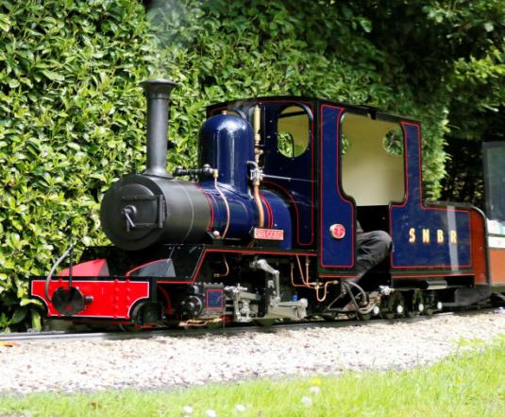

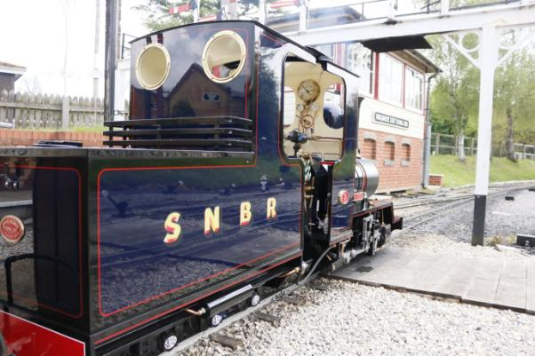

With the completion of Sir Goss’s overhaul the focus moves onto the rebuilding of ex cuckoo hill railway 2-4-0 tender loco Jupiter. Jupiter has been sold to a new customer in Cornwall and on completion of its rebuild the locomotive will be the resident steam locomotive of a recently reopened railway.

We will keep you updated on the progress of the rebuild over the coming months but we are hopeful this will be completed by the end of the summer holidays.

Our own overhaul schedule can now be prioritised with both William Rufus and Sapper out of traffic awaiting overhaul following expiry of their 10 year boiler tickets. Sapper’s boiler has already been retubed and has been hydraulically tested so the majority of the focus for Sapper will be on the chassis.

William Rufus is having extensive work completed including a new, bigger boiler that will make a big difference to the performance of the locomotive. As well as a new boiler we will be fitting all new valve gear to both of the power bogies and we have already re-bored the cylinders to a slightly larger bore.

We are excited about making progress with this overhaul over the coming months. *James Flay*

**An Introduction to the There and Back Light Railway**

I have had a lifelong interest in Miniature railways, I started helping at Stapleford in late 1994 with the tunnel rebuild and spent a good 8 or 9 years volunteering there during what I would class as the ‘golden age’ of progress with the railway. I pursued other interests for several years in motorsport and kiteboarding before returning to miniature railways in the early 2010s.

I had owned several locos in 5” gauge and 7.25” gauge before having the opportunity to buy the Bagnall presented itself, this was perfect for me, a larger engine and quite nicely built too… just what I had been looking for. I ran the engine for a good 6 months before My wife and I started talking one evening and the subject of portable tracks came up. We felt there was a gap in the market for a portable line serving the midlands (and beyond), the rest, as they say, is history…

The There and Back Light Railway officially launched in the August of 2019. Just three days after launching the business the Radio Leicester breakfast show broadcast live from our driveway in Melton Mowbray with the engine in steam on 30ft of track followed by the railways’ first Public appearance as a result of winning a Twitter competition to have our logo featured on the side of the Small Business Saturday tour bus. The train was taken to Oakham marketplace on the tour and displayed – albeit not in steam – in front of a national audience. Both media appearances led to a flurry of initial bookings and interest!

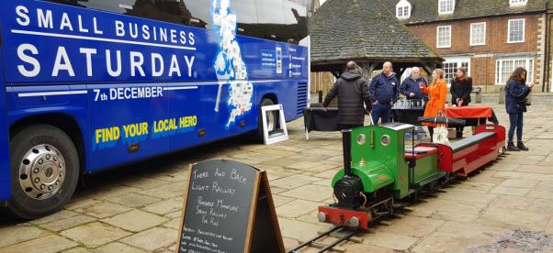

*The train on display in Oakham for Small Business Saturday during November 2019*

From the outset we decided we were not going to ‘play’ at this. We were going to look and act professionally and run what we termed a ‘slick’ and ‘modern’ looking attraction. We haven’t gone in for typical drivers uniforms, vintage signage etc for this reason, our competition is not with steam railways but with fairground rides.

Initially starting with just 200 feet of track we managed to attend a few events before Covid closed everyone down, but this short period was enough to get a feel for the direction the business was heading. We were targeting non-railway specific events and the success rate was quite high. A lot of effort went into marketing and building a brand which I think we achieved quite well

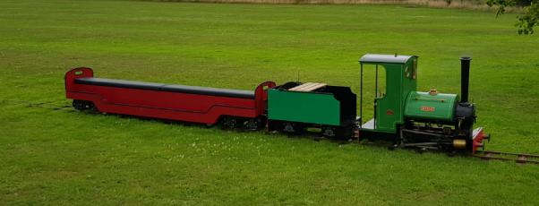

*New tender and 350ft of track in use in Naseby, Northants. July 2020*

The first lockdown not only allowed us to assess our strength but also our weaknesses – as a result the original ‘riding car’ for the loco was replaced by a purpose designed tender to not only match the loco better but give an elevated driving position for when running in reverse.

We also took this opportunity to extend our available line by another 150ft to make a total run of 350ft. Another addition was the procurement of a ‘Scamp’ type locomotive, number 88 ‘Moose’. This gave us a much needed back up loco should something happen to the Bagnall. Having upgraded our transport solution, July gave us opportunity to try the new kit out at Thoresby Park in North Nottinghamshire under new ‘covid-safe’ guidelines. We spent the remainder of the season between there and Matlock Farm Park running trains – albeit with reduced numbers – but running trains, nonetheless.

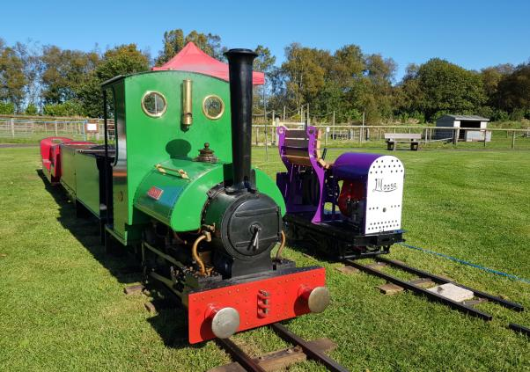

During November 2020 we added another 100ft to our running line, taking the total to around 460ft. this is the current amount we have available. This offers us a decent length ride for our passengers balanced against the practicalities of laying the track and transporting it. We managed just a few days running on the extended line before Boris gave us another enforced holiday.

During this short stint we were contacted by local TV Station, Notts TV. They wanted to film a short piece on the railway for their teatime magazine show about how small businesses have worked with covid and they forecast going forward. We got a great 5 minute segment with the train running and interviews with passengers and such, it even made it on their weekend roundup show for even more airtime! The final (hopefully) lockdown however allowed us chance to build another coach the same as our first – thus doubling our capacity.

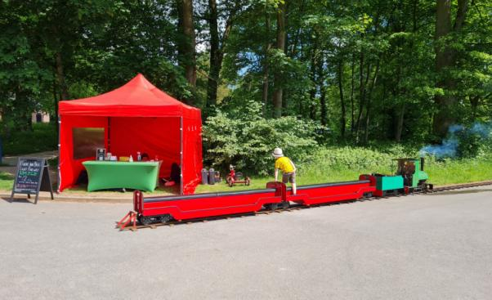

*Second coach now in operation on the 460ft railway at Thoresby Park in June 2021*

As I write this, we have undertaken a couple of days running under the current ‘relaxed’ guidelines and bookings for 2021 look very favourable – if everything keeps moving in the right direction! Diversification during covid has forced us to look for alternative revenue streams (haven’t we all!) and one part of that was visiting school with the railway. This is something we really enjoyed and now that they are teaching the Industrial Revolution again gives us something to work with. We find the kids really ‘get it’ with an engine of our size, not too daunting like a full size loco but not too small to be seen as a ‘toy’. We have plans for a second steam locomotive this year as well as another 100ft of track to allow us a bit of flexibility (including some curves). There has even been discussions about siting a permanent railway too but this is way off in the future!

Hopefully, the railway continues to grow, and we are pleased to be a part of the community. I know many of you already but look forward to meeting those that I do not yet and most of all look forward to working with you in the future!

**Swanley New Barn Railway**

We have for 2021 opened our railway in the same way we operated in 2020 with a fully socially distanced service. So we are presently running only from our main station, with a very reduced service and capacity. However we have seen some exciting things.

Firstly the build of Sir Goss is nearing completion at MVR, and the workmanship is outstanding. In addition our chairman has completed his double Fairlie. Which looks amazing and is a pleasure to drive.

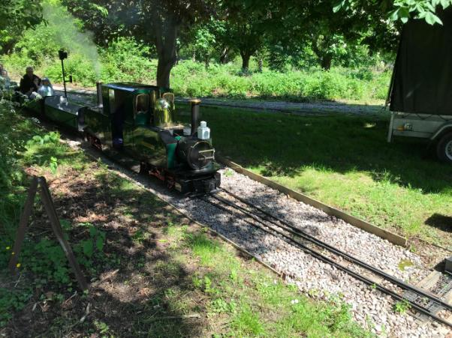

*The Double Fairlie – Y Sgwar powering into New Barn Station*

In the workshop, Owd Rosie is now ready for painting, this mean Prince Sheian is now in the workshop. The boiler is now gone off site for a re-tube. While the next job will be to build a completely new (and shorter) tender.

**Fancott Miniature Railway**

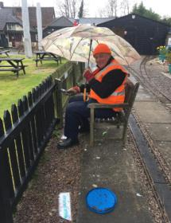The members of the railway have had a busy time cleaning up the site in readiness for re-opening to the public for the 2021 season. We were informed by The Fancott public house, in whose gardens the railway resides, that they were opening on the 17/5/21 and we could therefore open on the 22/5/21, this was then revised to the 1/5/21. So we had lost 3 weeks!

The members put in a tremendous effort - painting fences, tidying the site by weeding, trimming back the overgrown vegetation and replanting flower beds, 2 point motors were replaced and work was undertaken on drive train on Dark Star to return it to traffic. The ticket office was completed and new signage put up plus the tunnel entrance was repainted by one of our talented members, just to name a few jobs and all in a shorter period that we had planned for.

T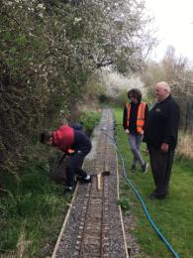he track modifications to remove the ‘S’ bend in the track were completed and we successfully ran test trains. Davanna, our steam loco, was fired up and ran it over the new track configuration as light engine, with carriages and loaded carriages with success. We are hoping this will allow Davanna to pull passenger trains in the future.

Here is a link to out Facebook page showing Davanna on a test run

- <https://www.facebook.com/100000031017497/videos/4301019823242342/>

We applied for a Central Beds Council Ward Councillor grant from Toddington Ward Councillor, Mary Walsh, which was successful, allowing us to complete our Ticket Office as part of the railways Covid-19 measures.

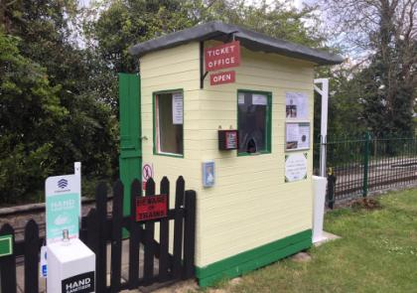

As mentioned previously we opened on the weekend of 1/5/21 and had a steady trade that weekend. Visitors have come from near and far, a family called in on their way to their holiday destination from Scotland and another family did the same travelling in the opposite direction.

Bad weather prevented us running on Saturday 8/5/21 but we were back on the Sunday, again bad weather struck on the following weekend of 15/16 with no running possible. The 3 day Bank holiday weekend gave us some great weather and kept the railway staff busy.

We also had our first school holiday running day on Wednesday 2/6/21, which gave us steady trade all afternoon.

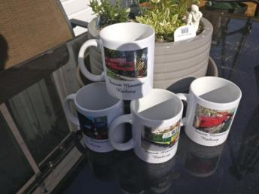We are getting great support from regulars and customers to the pub. Currently booking is still required through the pub website for the railway to comply with the track & trace requirements.

Our Just giving page has raised almost £600 and has now been closed as donations have stopped being received. It worked well but we feel that now we are operating and bringing in revenue it is no longer working. We are extremely grateful to all those who donated to help the railways funds.

We will be holding the following Fund raising events at the railway, so please make a note in your diary if you are interested in coming along -

July 24th & 25th 1960’s themed weekend/fancy dress

August 14th & 15th Teddy Bear days – kids bringing a Teddy ride for a reduced rate

September 18th Super hero day.

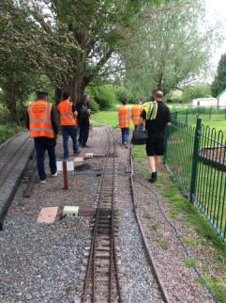We have also invested in some merchandise to sell to customers from our Ticket Office – we have china mugs with pictures of our loco’s on available singularly or a set of four and coming soon fridge magnets and Thomas the Tank engine flags.

The railway has received 3 bookings to date for special birthday party trains; these give the hirer, their family and friends plus the birthday boy or girl unlimited train rides for 2 hours. Balloons and banners decorate the station to greet the birthday boy or girl.

Here’s to a good summer – *Rob Winskell*

*Railway staff going home at the end of a good day!*

**Littlehampton Miniature Railway (LMR)**

The LMR reopened on 12 April this year and the railway has been busy ever since, as members of the public seem eager to get out and about and enjoy themselves and we all know that having a train ride is the best fun ever!

Our fourth modified Severn Lamb coach (No. 104) emerged from the works in time for the reopening; it is a welcome addition to the coaching stock, increasing the size of our normal rake from three to four vehicles. Like coach 101, number 104 is equipped with a wheelchair accessible compartment.

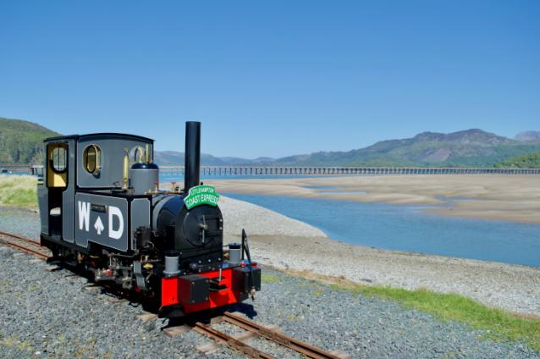

Our rebuilt Exmoor 2-6-2T number 4 has been named *Christopher* and in addition to the nameplates, the loco now sports WD lettering on the side tanks. *Daisy*, our wooden bodied tram locomotive has had its original petrol engine replaced by a Lister-Petter 3 cylinder diesel unit, which was part of a generator kindly donated to us by the Body Shop. In addition *Daisy* has received a new hydraulic drive unit and an engine driven compressor to supply air to the coach brakes.

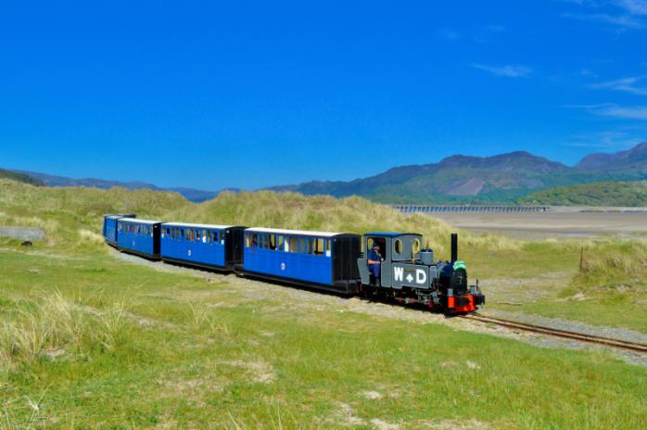

Both *Christopher* and *Daisy,* accompanied by four of our drivers, travelled to the Fairbourne Railway for their gala over the Bank Holiday weekend at the end of May. *Christopher* handled the longer eight and nine coach Fairbourne trains with no problems, the loco is a credit to our CME Tom Sanders who rebuilt the loco. *Dirk Shephard*

**Brickworks Miniature Railway**

As the COVID threat eased at the end of February 2021, small groups of the Museum's rail volunteers were allowed on site masked and working at suitable social distances.  Many of the more mature volunteers took great care not to come on site until they had received both of their jabs.

For the handful of early volunteers that did come in, the first priority was obviously to clear  all the weeds and undergrowth that had grown during lockdowns 1 , 2 & 3. All the spring rain had also damaged the main drive and whilst the digger was in sorting out the surface of the drive it was used to dig a trench  the foundation for the new railway crossing.

Cromar and White agreed to bend some heavier rail  to the 16m radius curve needed for the crossing.  In the meantime the new station  was slowly built up, slabs laid, buildings moved and modifed  as necessary, (the old signal box becoming the new ticket office!). Beginnings were made on  the 3 tracks into the new carriage shed as well as a production line of straight sections of track and sleepers  ready for the big  assembly!.  The long delays due to COVID means that the new track should be in operation for the 2022 season and hence we have spent a lot of time  readying the old track for rides in the 2021 season which began with the Spring event on Sunday 30th May .

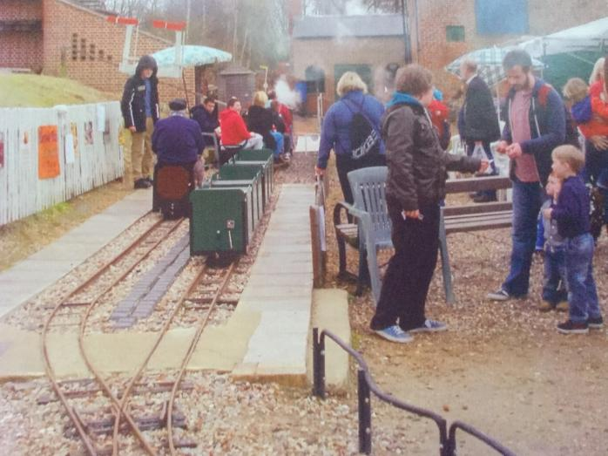

The 2 ft  line was in operation as part of the museum's WW1  women at War open day on Wednesday 2nd June.  We are in the process of setting up a local sponsorship deal where visitors can donate funds for everything from a single locking bolt , through a sleeper to a length of track. *David Hubbard*

**South Devon Miniature Railway**

Following our successful 2020 running season the whole country went into the second lockdown so there was no chance for us to start our much needed winter works programme. We had to wait a month before we could return to Buckfastleigh. On our return we started with a big clean up and to modify the elevated track in our workshop to create a wheel drop. First job with the new wheel drop was an inspection on Phoenix. Removing the wheel sets for the inspection was much easier and the good news was there was sufficient metal on the wheels to continue to use them for a few more months. We also sorted a loose bearing, greased the axles and Phoenix was fit for traffic once again.

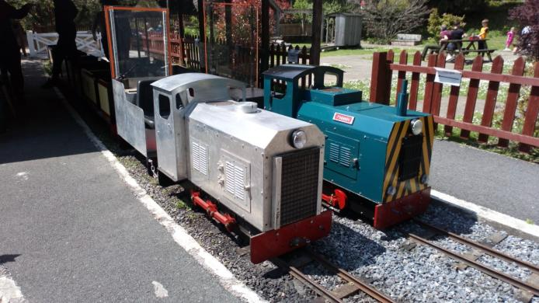During the running season we had to impose a Temporary Speed Restriction due to the condition of the track work between the tunnel and the S bends. Therefore as soon as we were able we lifted the track, levelled the track bed and started to relay using our stock of plastic sleepers. The big advantage of plastic sleepers is their resistance to Devon’s wet conditions which unfortunately causes wooden sleepers to rot

*The 0-6-0 out on some of her first passenger runs, with Phoenix having an easy day after assisting with the mornings works train, it has been many years since these two locos operated together. (C) P Crago*

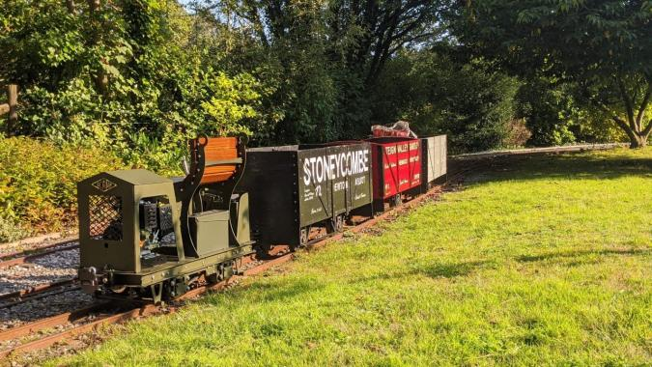quickly and have to be exchanged. Relaying track is a big task for our small team therefore we are slowly

*Scamp 80 out to play on a short demonstration goods, there may have been some work involved also I cannot remember (C) C Bines*

increasing the number of plastic sleepers which once laid require less maintenance. We plan to keep using wooden sleepers in our station areas. Just like full size track, the rail ends of the miniature railway also wear so we checked and trimmed some of the rails and then re-drilled the fish plate holes to make better joints.

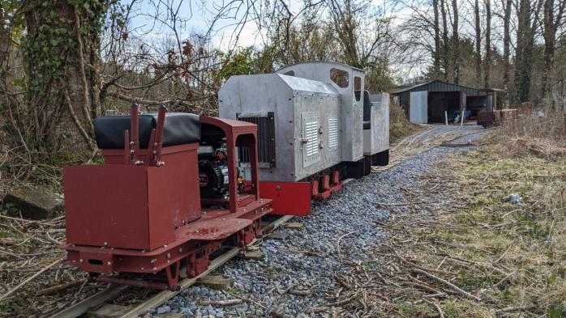

*Scamp No. 73 attempting to shunt its much larger shedmate the 0-6-0, either out of or into the workshop (C) S Cook*

Just as we completed the relay, the third lockdown started which has meant we had to pause our work at Buckfastleigh. However one project we were able to make some progress during lockdown was our 0-6-0 locomotive. Originally built around 20 years ago by our member Gary Cooper it had put in around 10 years hard work between 1995 and 2005, carrying out more duties than Phoenix, being an easier and more comfortable locomotive to drive. It then needed repairs but other work has meant it was always at the back of the queue behind by other projects. However now we are having to pull 3 coach trains the 0-6-0 is required for traffic and a push was made to complete it. The locomotive originally carried a 5HP Engine and it has now been fitted with a 10.5HP Honda so is much more powerful. It is also fitted with an Eaton 11 Hydrostatic gearbox, meaning it will be a completely different driving experience to Phoenix as well. The 0-6-0 is actually numbered number 2 as it was on the railway before Phoenix and has now entered traffic. Once we are happy all the snagging effects have been resolved it will get a new coat of paint and be named Pegasus.

With the easing of some of the Covid restrictions after the third lockdown a small group of SDMR volunteers assembled in March for a big push to ensure we could open the miniature railway and offer a public service as part of the site attraction before the full size South Devon Railway could restart their service. Several faults were found and on one weekend we relayed two points at the station, fixed other defects and altogether re-sleepered around 160ft of sleeper material in this area. A second weekend saw us carry out an in depth track survey and replacing over 60 sleepers. This meant the railway opened on schedule and we saw very healthy passenger figures in the warm and dry April weather.

Once we started running other defects appeared and we also had to do a few early morning emergency repairs. On our S-bend the warm weather caused the rails to expand and push the screws out of the sleepers. This caused the track to go out of gauge. This was quickly rectified with some new sleepers over a couple of mornings.

Not every day in Devon brings dry weather and as our carriages and locomotive are open to the weather we don’t run in the rain as we have found we get very few people requesting a ride.It can also cause damage to the locomotives and the coaches as neither are very waterproof! However that does not mean the staff have not been busy on rainy days.

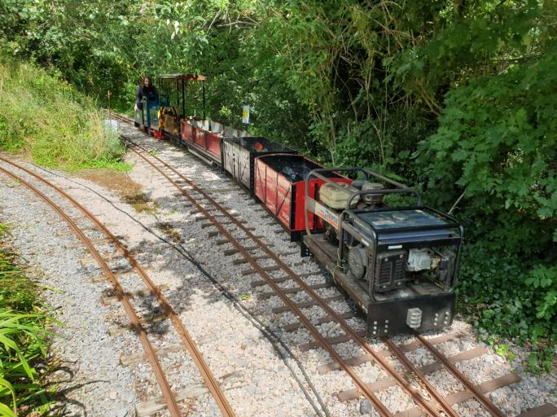A longer term project is a bogie locomotive, driven by a three cylinder diesel engine and with an outline

*Phoenix out on works duties at the top end of the site at Dart Bridge Loop. (C) K Stapleton*

modelled on a British Railways class 25. It is already on the rails at the back of the workshop and we hope that this engine will be available towards the end of this year.

At the other end of the scale two members have got a Scamp locomotive each. These small petrol electric engines are surprisingly strong, capable of pulling a couple of wagons and therefore ideal for Permanent Way trains. On most running days, before opening the public service, we do a couple of hours either trimming back the vegetation or some PW work to try and stay ahead of the maintenance. The Scamp is ideal to help with transporting tools and supplies *Kelvin Stapleton*

**Whitfield Light Railway**

The railway reopened on the 13th April and has now ran 38-days to-date. It’s been a promising restart given all the current uncertainty, with April being good, May affected by weather and June alright through the Whit holidays.

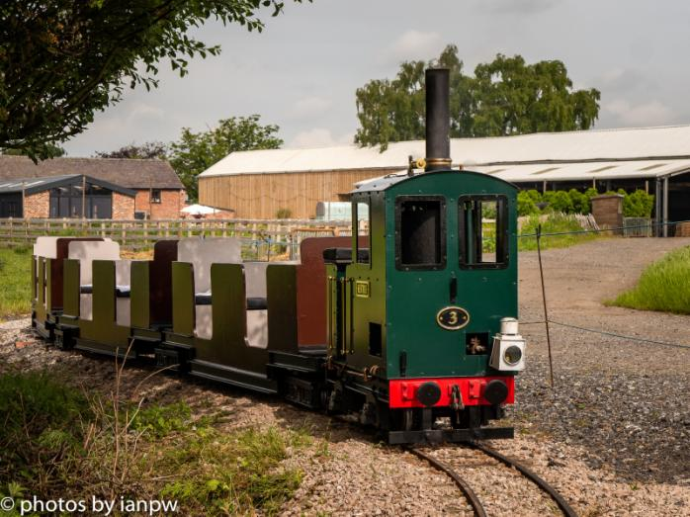

It really feels like I’ve been restarting the business, as the model has changed and I’ve moved away from the event business. Covid has forced that hand.

The current global climate of Brexit / Covid / Suez blockage, has led to much increased costs across the board - everything appears to have doubled in price - timber, metal and so on. So for a restart to a small business, it’s been challenging.

The railway for the April reopening needed to be rebuilt - I ‘lost’ 50m up to the car park, due to problems around social distancing at a pinch point on the site; I then ‘gained’ 100m alongside a wooded pond area, so the railway is now longer than it’s ever been. That continuum to becoming more permanent means the infrastructure starts being more substantial and the need to involve contractors for certain work aspects.

So, keep moving forward - the railway largely open for 4-day weekends Friday-Monday, and through school holidays.

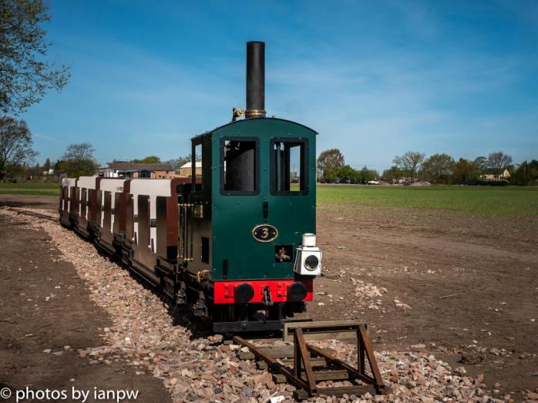

**Newsletter prepared and circulated by**

Tony Davies, Short Acres, Tiptoe Road, Wootton, New Milton, Hants, BH25 5SJ

Tel No – 01425 616622.   
e-mail – dublorunner@gmail.com

All photographs are the copyright of the Railway featured in the article, unless stated otherwise.

**BRITAIN’S GREAT LITTLE RAILWAYS Ltd** Registered Office:- Moors Valley Railway, Moors Valley Country Park, Horton Road, Ashley Heath, RINGWOOD, Dorset BH24 2ET  
Registered in England & Wales - Company No. 3143331

BGLR Website – [www.bglr.org](http://www.bglr.org)