Britain’s Great Little Railways



|  |  |
| --- | --- |
| **Newsletter 81** | **January 2021** |

**Chairman's Letter to Members**

I hope you are all keeping well in this latest lockdown, at East Herts we managed a couple of running weekends in December before we were placed into a Tier 4 area, just before Christmas, so we are now closed for the foreseeable future.

We are planning to host another of the Zoom virtual discussion meetings, which some of you have previously attended on Monday 8th February 2021 20:00 – 21:30, those railways who have attended in the past have already received an email but if anyone else would like to join us then please email [ollie@ehmr.org.uk](mailto:ollie@ehmr.org.uk) and he will add you to the invite list.

The Directors of BGLR have decided that for the coming year we will not to charge members the annual subscription as we are currently in a reasonable financial position and due to the very limited running that most of us have had, we will have plenty stock of the current leaflets and posters so we will not need a print run of those this year.

For the AGM this year we will probably look to host some form of virtual online event around March, EHMR are having an online AGM this week so we will see how this goes and will report back to the Directors in the next week or so.

Best Wishes for a successful 2021 once we can start up again.

Regards, Iain Dinnes, Chairman - BGLR

**BGLR NEWS**

I would like to welcome on board two new members for 2021.

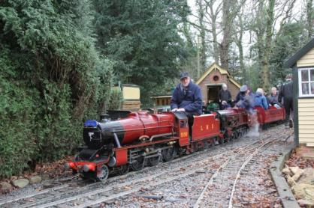The first is the **Ingfield Light Railway** run by Craig Gluyas at the Ingfield Manor School in Billingshurst. Originally established in 1973, it is a private 10 1/4" gauge railway situated in the grounds of the school. It consists of approx 3/4 mile of running line in an end to end "Y" layout with both single and double track sections. The school is for children aged 3-19 with neurological motor impairment and the railway not only helps to raise funds but is also a source of great enjoyment to the children and their families. They operate at various school events held throughout the year including the famous "Fete Day" when an intense service is operated. At other times the line is available, by appointment, for group and society visits.

The second is the GLMR portable miniature railway which is subject of an article in this Newsletter.

**HRA, LEGISLATION, & SAFETY REPORT**

*BGLR is a corporate member of the Heritage Railway Association. Members can read HRA “members only” publications on www.hra.uk.com/ by entering the username* bglr *and the password* kcnsy37

The HRA members section has a very good webpage giving weekly updates on the Corona virus legislation and how it effects their members. The latest update (January 15th) gives details of the Supreme Court ruling on Business Interruption Insurance which could be of interest to some of our members. Access details above.

**NEWS FROM OUR MEMBERS**

**Thompson Park Railway**

2020 saw us having to cancel our Santa Special totally for the first time ever. The first picture shows the railway on Boxing Day in 2015 after the River Brun burst its bank and flooded the park along with about 70% of our track. We got the railway up and running ready to start the season but  one stretch was not cleaned. So this year because the season was curtailed we decided to repair this final stretch of contaminated track.  This stretch is what we call the riverside and it is 71 metres between the crossings. The track was lifted and all the contaminated ballast was removed. In January we should have some everedge delivered and after this has been installed we will re ballast and replace the track.  The other pictures show the work in progress. All being well we plan to reopen to the public just before Easter. *Mike Bailey*

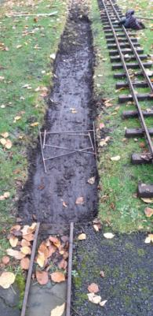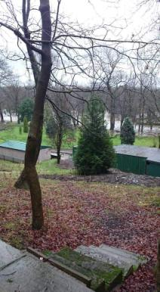

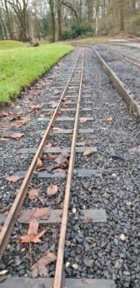

**Strawberry Line Miniature Railway**

Well here we are in 2021 what a whirlwind time to be a railway 2020 was. We hope you are all doing well in the unprecedented times. So as many of you read in the last newsletter we started on the road to regauging to 7 ¼” now we were lucky enough to have run for the public during summer holidays, halloween and christmas so progress has been slow. However heres some pictures of what has progressed so far.

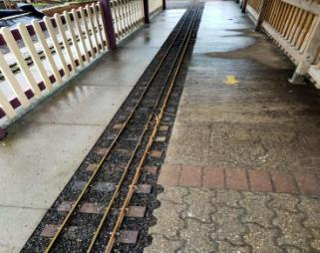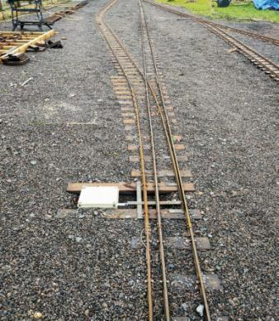Platform has had some concrete removed for the wider sleepers and the only dual gauge part of our circuit has been installed and levelled (once) but has long since settled so will need another lift.

Just outside the platform we come to our rather unusual point. This will be operated on the train release the will only change the blade if the 5” gauge wants to leave. We have yet to run anything 7 ¼” through it.

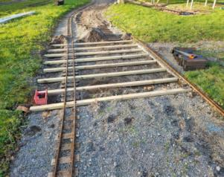

Heading to the bottom corner we have our new (soon to be) decked level crossing complete with automated crossing lights/siren

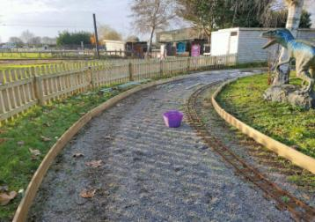

Bottom corner has been boarded to allow track to be lifted to avoid the dip that always floods and alleviate the steep incline

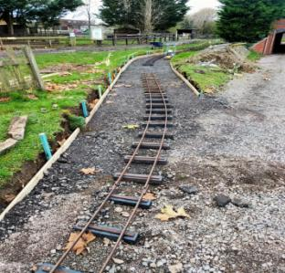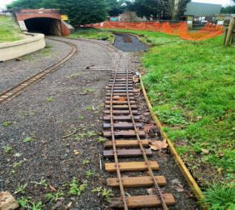A new cutting has been dug out round the tunnel (which is only 5ft tall) and we purchased some premade secondhand bar railway to complete this section

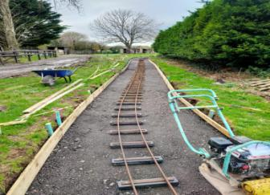

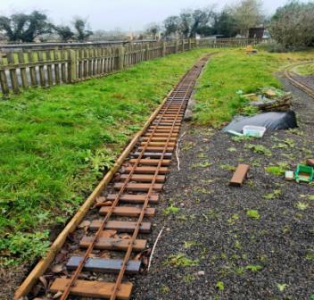Other end has a point to the tunnel that will be for storage for ease of operation

Then the next section has been gauged and is ready for ballast to the top corner. The longest part of our system is soaking sleepers in creosote which gets us 100 sleepers a week which you'll all know doesn't go far at all. Still we are aiming for completion and testing from end of February, coaches are ready for delivery we just need to get a section completed to allow for unloading to the storage. I hope 2021 brings us abit more normality at some point and we all get to catch up soon. In the meantime stay safe everyone. *Regards Chris and the team @ strawberry line*

**GLMR**

I am pleased to report that my efforts over the last year have not been in vain!

When deciding upon the location of the railway I was hoping to build, the pandemic showed that I was going to need to be more dynamic in the way I went around things. With this in mind, I decided that moving the railway to people would be a better idea than constructing a permanent line in a single location (especially considering the current climate).

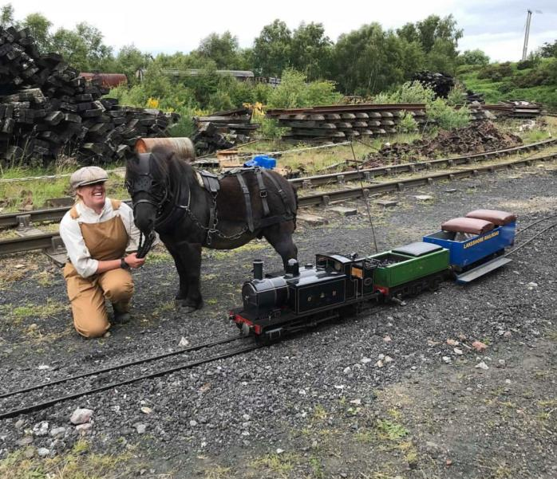

Therefore the idea of operating a portable miniature railway seemed to be the best solution. Over the past year I have undertaken a vast amount of research in order to properly understand my target audience and learn what the most suitable set-up would be. For this reason, I decided to opt for 1.5m track sections supplied by Daniel Mason at Miniature Railway Workshop, this would be in addition to my current lengths of aluminium track section. This will allow the railway to be quite a long ride for a portable line, and it will also allow the railway to be adaptable for different situations.

The locomotive of choice is Scamp no3, part built by Colin Edmondson (the designer of these ingenious little locos, of which there are now over 100 built). We also operate a smaller sit astride carriage which can be easily transported in the van.

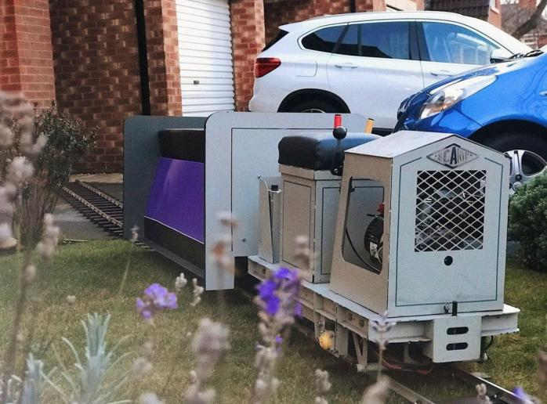

Over the past couple of weeks I have received confirmation for two recurring local events here in the North-East (starting March- touch wood!), which means we will be operating, at the very least, twice a month. I have recently published the new website ([glmrailways.com](http://glmrailways.com/)), and we have ever growing social media channels which I hope will boost our presence in the local area.

I would like to thank everyone for posting in these newsletters over the last year, it really offered some great guidance and inspiration - I can't wait to get started!  Thanks very much, *Patrick Allen, GLMR - Portable Miniature Railway Hire UK.*

**North Bay Railway**

After what we think was a successful summer, all things considered, we turned our attention to our winter events.

Halloween we felt wasn’t a viable option given the circumstances. With this in mind we focused our attention to the Santa Specials.

We spent a week or so playing hokey cokey with the government and council, but finally found out we could go ahead as planned. We, like many others, were lucky to be in Tier 2 but could not accept any bookings from Tier 3. Sadly this meant many people had to be contacted and refunds given, and a great deal more told they couldn’t book. We also lost two weekends, which meant lots of admin moving people and adding trains to accommodate them.

The event however ran very smoothly. Covid had forced us to take a different approach, and I am happy to say that this was successful. Much of it will be carried forward into a (hopefully) non covid affected Santa 2021!  If the number of cancellations were added to the total people carried we actually had the most attended Santa event we have ever had. This is largely due to the lack of any other Santa events in the local area, but hopefully people will visit again in the future.

Looking forward to 2021, we are planning for this season is going to be as covid affected as the last. From there things can only get better!

I have included our 2019 and 2020 mileages for a comparison as to how affected our season has been.

2019 2020

Neptune 2156 986

Triton 1672 1394

Poseidon  2440 728

Robin Hood  38 678

Georgina  1288 512

Locomotives Total 7594 4298

Coaches Total 7392 4150

*Steve Johnson*

Steve didn't send a picture with his article so I went to his website to find a picture of one of his engines and found this - just wonderful.

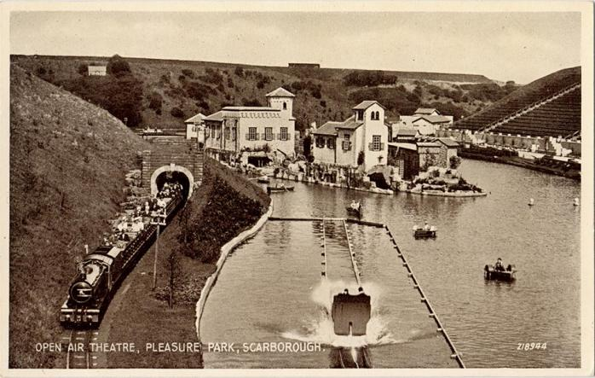

**Evesham Vale Light Railway**

Well what a year that was, and hopefully once the vaccine starts to have an effect, we can get back to some form of normality.

We operated over the whole of the summer holidays, and we got busier as people’s confidence in our Covid precautions grew, to the point that the last couple of weeks of the summer we were as busy as last year.

We were able to operate our Santa Specials very successfully with a Socially Distanced Santa, and were sold out every day, with a waiting list for cancellations.

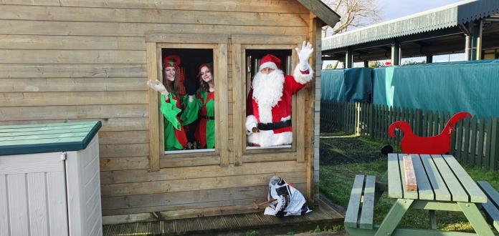

Along with every other Railway, we are now closed for lock down # 3, but are using the time to continue with our carriage refurbishments, with the latest carriage to receive attention re entering traffic in October and to finish off even more of those “I’ll do that one day” jobs. *Adrian Corke*

# Swanley New Barn Railway

With the end of the 2020 season, work concentrated on winter activities. These have been massively hit by Covid.

Over 2020 we progressed the rebuild of our large Tinkerbell variant Owd Rosie. She has now almost ready for painting. With the work including: being lengthened to get a larger cab (for bigger people), which has a removable roof. A new boiler, new chimney base, smoke box, all new piping, new pistons and new piston rods.

We hope Covid permitting that Owd Rosie will return to service in 2021.

On the engine front the rebuild of Sir Goss at Moors Valley is progressing very well, and he is looking amazing.

On the coach front, we are rebuilding our blue coach set with all new bodies, and different metalwork. Again Covid permitting these should enter service in 2021 as well.

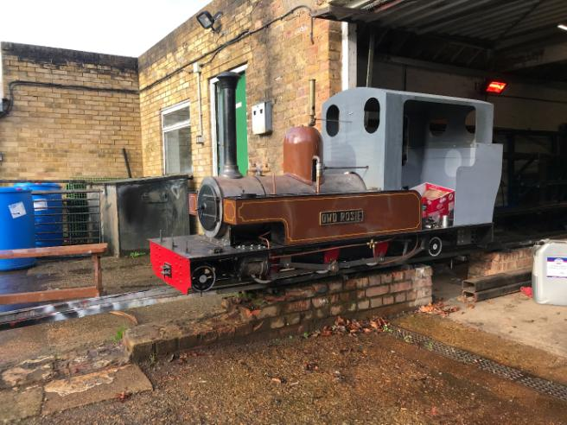

**Brickworks Miniature Railway**

**Before Lockdown:**

We have had the digger in and several small, self-seeded trees have been removed from the new route. The top (car park) loop has been dug out and levelled, as has the route from the 2’ station to the crossing above the 7 1/4” shed and then dug out to the first corrugated shed. A lamp post that was in the way has been taken out and the heavy brickworks machinery has been moved, so the whole route is now clear of obstructions.

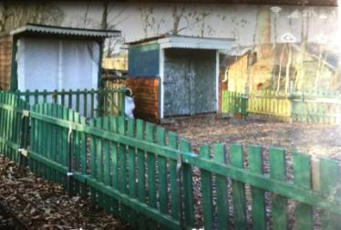

A major piece of work which has been completed is the inclined railway from the 7 1/4” main shed up to the new level. This was tested by our test pilot John successfully using his Planet loco. This means that the plan to keep this shed as our main loco shed and workshop is now confirmed. The two corrugated sheds at the upper level will be kept with the first being used as the carriage shed and the second for the storage of items that will save us going backwards and forwards to the main shed when working. Work is underway to alter the door on the first shed so that the front opens completely and so that 3 tracks can be installed.

The summer patio has been cleared and daffodil bulbs planted which will make the area tidier and prettier in preparation for the planned visitor route to the new station.

**Wider changes at the Museum:**

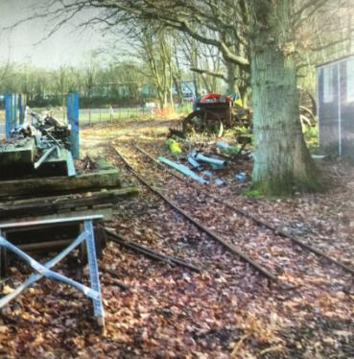The outdoor brickworking displays are being updated, hence the roadway from the main driveway past the horse gin and the Pyecroft building, which is currently under construction, will be split to form a separate footpath and roadway.  This development will allow a better flow of visitors to the 7 ¼ track and then to the outdoor steam engine.   To achieve this we will extend this path to the railway crossing (at the top of our slope), cross the 2’ to come to the site of our new 7 1/4” station, where we will have a larger area to accommodate push chairs, our ticket office and sales stand.

**Where are we at the moment?**

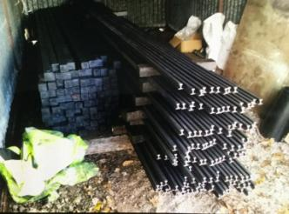

We have agreed a deal with Cromer White to supply profiled rail, sleeper material, fishplates and track fixings at a price we can afford. Thanks to the second Lockdown arrangements 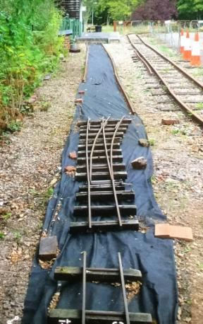and the later Tierings the rolling mills have only just restarted production hence delivery did not occur until mid December.   In between lockdowns we have also managed to get (delivered) the first 20 tonnes of limestone chippings for the track bed. We are also still looking for donations as the more we raise, the more we can afford to do, especially as we don’t have any passenger income at present. The new station site will need levelling and there is a lot of ballast to be recovered from near the main gate.  (Hopefully this old ballast can be recovered when we repair / recamber the main museum drive, once it stops raining).  We plan to move the “signal box” tool store to the top level and convert it for use as a ticket office and also to move one of the 2’ station sheds to convert to a proper sales stand.

 With all the delays caused by COVID it is likely that the old 7 1/4 track will still be in use at the beginning of the 2021 season,  however hopefully the new track will be up and running by late summer. *David Hubbard*

**Moors Valley Railway**

A new year but unfortunately not the to 2021 start any of us would have wanted we are sure. We took the decision to close from December 30th following the tightening of COVID-19 restrictions and since then as we all know lockdown 3.0 has started. The end of 2020 was quieter than normal for us as we didn’t hold any Santa Specials for the first time in 30 years; November was spent in lockdown 2.0 and December passenger numbers were impacted by local tier restrictions close by. After a very different year we ended up carrying roughly 20,000 passengers less than normal with our end of year figure being close to 80,000 thanks mainly to a record July and a very good August. Our hope is that the Great British staycation remains in 2021 and that should the sun shine we will have a positive holiday season again.

Whilst the railway is closed the core team remain in work with lots of work to get on with in the workshops. As we reported in October Lord Randall’s overhaul was complete and we returned it back to Lawrence Martin and the Wayside Light Railway in November. Since then the workshop has remained focused on the completion of Sir Goss’s overhaul and the start of another rebuild for a customer in Cornwall.

The rebuild is of 2-4-0, ‘Jupiter’ which ran at Bob Kinnison’s ‘Cuckoo Hill Railway’ in the New Forest. As we mentioned in the May 2019 newsletter Jim purchased the railway following a period of closure and it was our intention to return Jupiter to service. Jupiter was originally built here by Jim in 1991 and is the sister engine of our resident 2-4-0, Horton. Whilst we had planned to return Jupiter to service the opportunity arose for us to complete the rebuild and sell on the engine to a customer who was looking for something like Jupiter for the railway he had just taken ownership of in Cornwall. Jupiter will this way see far more use in service than it would have if it had remained with us. We will keep you updated on the progress of the rebuild as it happen, however by the time you read the next BGLR newsletter we hope it will be complete and already at its new home.

Just before Christmas we took the opportunity to introduce Sir Goss’s engine with tender outside of the workshop. The first time this has happened for a long time, we have included some pictures below for you. Since then we have stripped the loco back ready for shot blasting and painting. Again by the time we send a write up for the next BGLR newsletter we expect Sir Goss to be finished.

In other railway news we have also made some progress on a couple of our own locos overhauls. Sapper has been out of traffic since 2018 following many years of hard work at both Tucktonia and here. The boiler has been re-tubed and the chassis completely stripped for inspection, Sapper is unusual as it is our only inside frame locomotive so we are taking this time to make some much needed improvements that will see the locomotive return as an even more useful engine than it was. Work has also continued on the Garratt’s overhaul, William Rufus has been out of traffic for some time as it was decided on withdrawal that it would benefit from a new, bigger boiler and significant improvements made to the power bogies. As these overhauls continue we will keep you updated.

Finally we announced before Christmas that we have also started a new private project for a new locomotive to join the fleet here. The design is based around the Ffestiniog railway based ALCO, Mountaineer. Whilst work is still very much in the early stages we have completed the driving wheel sets and the boiler is on order. Again we will keep you up to date on this new build as and when things progress.

Don’t forget you can keep up to date with all of these things on our locomotive works Facebook page here - <https://www.facebook.com/kingsmereworks>

To find out more about the work we offer as part of our Narogauge Services you can visit our new website and the designated page here - <https://www.moorsvalleyrailway.co.uk/narogauge-services/>

# \\mvr01\UserDocs$\James\Downloads\Goss.jpg

# Whitfield Light Railway

# So the last weekend that the railway ran before lockdown 1 was 14-15th March. It’d been a pretty poor first few months of 2020 with the wet weather. With the relaxing of restrictions in July, The Hayloft reopened and I set about rebuilding the railway. The shielding at home meant a cautious reopening on the 24th July. The Covid secure operation evolved over the summer, eventually I opened up 14 seats / 7 bays of the 4-car artic set and left the one closest to loco and myself closed. That allowed a more flexible loading, as family sizes aren’t set! For example, load a family of four, leave a bay, load 2, leave a bay, load 3, then the closed bay. Typically it meant carrying loadings in the 8-10 people range.

# So the social distancing reduced the capacity by 1/2 but more people were on site, so trains were running fairly full on most occasions. Across the year, I ran the train on 80-days but unfortunately too many were wet weather related. The 80-days was half of 2019, and in approximation meant half the passengers and half the income. That was even though running the larger train set, compared to a single coach in 2019.

# whitfield1.jpg

# Back to Covid. Lots of cleaning. I’d clean down the artic coaches and then spray with Zoono long term sanitiser. Then after each seat that had been occupied, the high touch places and dirt would be cleaned with antibacterial spray. St Helens council environmental health inspected the railway and were completely satisfied with my risk assessment, process and practice. They also said individuals needed to take their own responsibility around Covid but unfortunately too many don’t. That would bite back in October. Interestingly I could now do a return trip every 10-12 minutes, which is about double of that achieved on the busiest days in 2019 with a single coach.

# So social distancing has reduced capacity, and I’ve the ability to run less trains due to cleaning, and boarding / disembarking instructions. But have a bigger train out.

# So the summer was surprisingly busy, September quieter, and October bedlam - every day, maxed out, 9-5. It also highlighted the steam tram no.3 ‘Kestrel’ was working beyond its capability, with 3-days lost due to a slipped wheel and struggling to raise steam due to a blocked chimney. The weather in October was awfully wet too, following a months rain on the first Saturday. It was a struggle to keep the railway out of the water, as the site turned to a mud-bath. There was increased line walking by the public, as it was the driest bit of land. Eventually on the Tuesday before the month end, I closed the railway, due to the public not behaving and not following the then Tier 3 restrictions.

# whitfield5.jpg

# November was Christmas set-up in Lockdown 2, ahead of a possible 14 running days in December. Unfortunately the continuing pattern of wet weather meant the railway managed 3 poor days before closing for the winter and ahead of Lockdown 3.

# It’s unclear when reopening will occur following Lockdown 3. That is planned to be at The Hayloft, with the event business now gone, with that sector disappearing due to Covid. In the meantime, all the Christmas decorations have been returned to storage. On winter maintenance, all the coaches are largely ready to go, subject to the usual checks. Steam tram no.3 ‘Kestrel’ needs her 1906 Locomobile engine out for, we believe, new piston rings. Our works shunter no.4 ‘Otter’ (petrol-electric loco Scamp no.31) needs a good service. And a chassis and hydraulics from Southern Miniature Railways (thanks to Charlie O’Mahoney) is being rebuilt into a six-coupled diesel-hydraulic no.5 at AMW Light Engineering - the aim is she becomes the prime mover for the railway*. Ian Whitfield*

# Fancott Miniature Railway

# Halloween - The FMR’s last big event was our Halloween spooky specials on the 24th October. Despite the bad weather – windy with heavy rain showers – we had a really good turnout and support from passengers and the public. Our members spent the afternoon decorating the railway with lots of animated figures, cobwebs and skeletons to give the passengers a hair raising experience. Costumed riders were given a small spooky gift to reward their efforts.

# FMR halloween 1

# FMR halloween 2

# Last running day – was Sunday 25th October, the staff that day removed the Halloween decorations from the trackside, loco’s and tunnel before passenger rides commenced. Compared to the previous evening’s rain the weather was fair and bought out lots of passengers and regulars to say farewell to the railway for the winter period.

# 

# Track realignment preparations had been started – see below – with the track move planned to take place and be completed before the 6th December when we were going to run the Santa Special trains on the 6th, 12th and 18th of December. Alas this was not to be as Luton/Bedfordshire went into lockdown and it was considered too greater risk to railway staff and passengers to run the trains.

# New Track - digging out 1Track realignment - Preparation work had begun in early October clearing the lineside vegetation and digging back the bank to make way for the new track bed. Supplies of ballast, sleepers and fittings were delivered to site in readiness for relaying the track to remove the curve on the hill to give a straight run from the tunnel curve to the bottom loop point.

# Foundation MOT material was laid and tamped down to give a firm bed in the newly excavated area, followed by shingle, weed proof membrane and a layer of ballast. The track sections were then constructed in the warmth of the engine shed and transported on a works train to the end of the existing track from where they were manhandled into position. Trackside boards where staked in position to retain the ballast and help keep it compacted, reducing maintenance and ballast loss.

# New Track - layingThe track was positioned and then ballasted before carrying out the final gauging and levelling. Phoenix took the first works train along the new section of track without any problems. Further test trains will run to allow bedding in before rechecking all alignments in preparation for the 2021 season.

# Future projects – plans have been drawn up and materials are being sourced to construct a ticket office/booth at the station platform entrance. This will allow better protection from the weather for train staff and also the safe keeping of takings and our credit card machine.

# New Track - laid2021 Running – Traditionally the railway reopened to passengers on Mother’s day, however we have been informed by the Management of the Fancott public house that the pub will not be opening until early May depending on local and national restriction in place at that time. It is hoped that the completion of the new track alignment and essential maintenance will be allowed before that time so the railway members can be prepare the track, rolling stock and loco’s for public running. *Rob Winskell*

# New Track - ballast train

I have received the following request from the **Great Laxey Mine Railway**:

Whilst the Pandemic has not hit the Isle of Man as hard as it has the UK (we had had no restrictions at all for six months up to a couple of weeks ago, now we are currently back in lock down) the absence of tourists from the UK, and beyond, led to a significant reduction in income and consequently we are looking at opportunities to reduce our costs.

Being only a small operation, open only on Saturdays from Easter to September plus a few “specials”,  the most significant cost we have is insurance. Are you aware of any Insurance Companies offering competitive schemes for railways covering both boiler and operating insurance. Does BGLR have any tie ins with any particular insurance companies.

Any help you could offer us with exploring the possibility of obtaining cheaper insurance with alternative companies would be gratefully received. If you personally cannot help could  you point us in the right direction to someone who might be able to?

If anyone can help please contact Ian Smith, minerailway@manx.net

They have been members for many years and are frequent contributors to the Newsletter so I hope that you can help them.

Finally a heartening picture from Ian Whitfield to remind us that the good times will be back

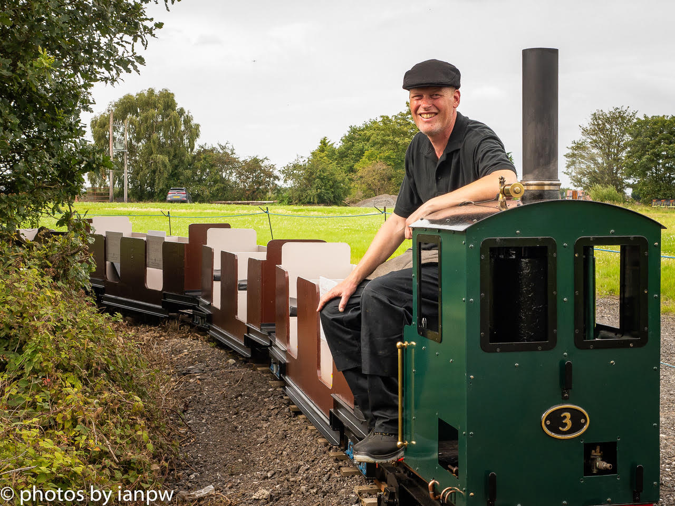

**Newsletter prepared and circulated by**

Tony Davies, Short Acres, Tiptoe Road, Wootton, New Milton, Hants, BH25 5SJ

Tel No – 01425 616622.   
e-mail – dublorunner@gmail.com

All photographs are the copyright of the Railway featured in the article, unless stated otherwise.

**BRITAIN’S GREAT LITTLE RAILWAYS Ltd** Registered Office:- Moors Valley Railway, Moors Valley Country Park, Horton Road, Ashley Heath, RINGWOOD, Dorset BH24 2ET  
Registered in England & Wales - Company No. 3143331

BGLR Website – [www.bglr.org](http://www.bglr.org)