Britain’s Great Little Railways
Newsletter 78 | April 2020

BGLR SHUTDOWN

"Who would have thought" that when members from 18 railways met at Watford Miniature Railway to attend the AGM, Spring General Meeting and distribute brochures and posters that within 12 days the country would be in lockdown and their railways shut down?

But that is what has happened and now no one knows when they will be allowed to reopen.

I hope that somehow you are able to preserve your railway's operation and that you will be able to reopen when you are allowed to.

In the meantime stay safe

BGLR NEWS

For a few days in March the front page of www.bglr.org reflected the current situation at each railway showing whether they were open or closed but continuing government restrictions soon showed all railways as closed. I will maintain this front page and as and when railways are allowed to reopen I will again show whether a railway has reopened or remains closed. Your help in updating this status would be very welcome when the time comes.

At the AGM we welcomed on board Brickworks Miniature Railway, Brookside Miniature Railway, Lappa Valley Railway, North Weald and District Miniature Railway and the Riverside Miniature Railway and said goodbye to Bickington Miniature Railway, Cinderbarrow Miniature Railway and the Rhiw Valley Light Railway.

Thanks to members attending the meeting 25 boxes of brochures were distributed at the meeting with the rest being posted although I am sure that they are still in their boxes.

Also at the meeting Peter Jackson retired from the post as Treasurer and Roger Brown from the East Herts Miniature Railway kindly volunteered to take on the role. There will a handover after all last year's paperwork has been completed,

It is still hoped that the Autumn General will take place at the Barnards Railway, Barnards Farm, Brentwood Road, West Horndon, CM13 3LX on Wednesday October 14th but I will keep you informed as we get nearer the date

It must be time for a photo of Roger Brown contemplating his new role whilst riding on the Watford Miniature railways along with other members, thanks to Ian Whitfield for the picture.

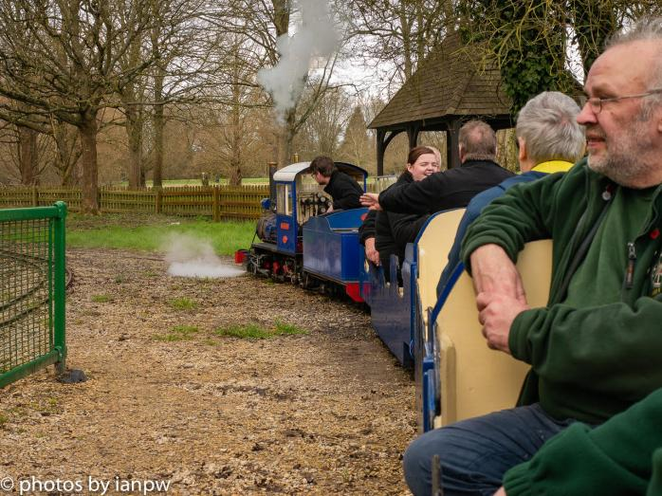

HRA, LEGISLATION, & SAFETY REPORT
BGLR is a corporate member of the Heritage Railway Association. Members can read HRA “members only” publications on www.hra.uk.com/ by entering the username bglr and the password kcnsy37

This is the latest information available from the HRA site

COVID-19 CORONAVIRUS

The HRA continues to work extensively on your behalf in providing advice to members, monitoring government announcements, and working with colleagues elsewhere in heritage and tourism to forcibly state to Government the impacts on heritage rail and to push for changes and revisions on key issues.

This page is where you will find various documents, links and updates that will be useful to our Members in developing measures to deal with COVID-19. (Please note, however, some items are sent directly to senior management within member organisations, which are not always reposted on this site).

We should stress that the HRA is made up of different styles of operators, and the information below will, for many, already be being used.
Visit Britain have a useful page of tourism-related news and information for UK tourism businesses, and the Heritage Alliance with whom we work, has put together a comprehensive ‘directory’ of advice links, including all the main Government updates, guidance notes and initiatives.

Rather than the HRA replicating this work, links to these are below.

The Heritage Alliance Covid-19 Guidance Hub can be found HERE

Visit Britain’s COVID-19 - latest information and advice for businesses can be found HERE
For ease, we also highlight a handful of key general links to Government advice which we know Members are finding useful:

Specific Government advice for employees - here

Specific Government advice for charities - here

General information on Covid-19 - here From this page there are many links to more info such as to NHS.UK.

Another useful page is the NHLF Heritage Emergency Fund
NEWS FROM OUR MEMBERS

The great revamp at Bentley Miniature Railway
Glyndebourne Wood Junction

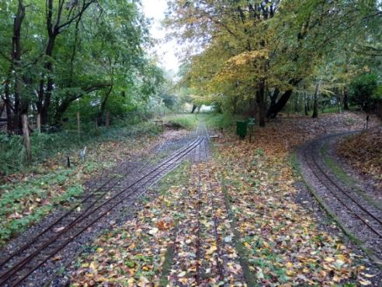
A couple of years ago our Operations Committee approved a project that would give the station at the woods a much needed by-pass route for trains arriving from our Bentley East station. This is needed so that queuing of trains on our busier days can be reduced to a minimum. Our other two stations already have a second line, so that if there is an issue the blocked platform can be by-passed.

The new platforms are long enough to accommodate two trains of loco, 3 coaches plus guards van in each, so on busy event days there should be no delays.

A water crane and coal bunker serving both platforms will be situated at the departure end and a second water crane situated just before halfway so locos can take water while unloading, if needed. A foot crossing will be placed halfway along the platform, giving direct access to the woodland area without having to walk all the way back to the existing entrance.

From the engineering aspect this project has reused all the existing GW points with the option to build an additional one to make a reversible siding and train turning facility. Two new diamonds are required but these are simple to make. The short chord on the route from Bentley Central towards Bentley East had one of the tightest curves on the railway with poor visibility and has been removed, effectively replaced now by a straight-line crossing. This will make it possible to have an automated crossing control barrier in the near future.
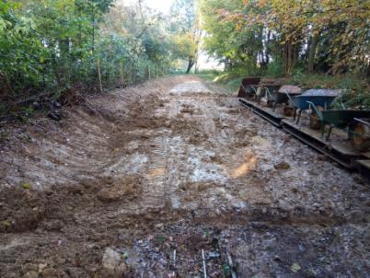
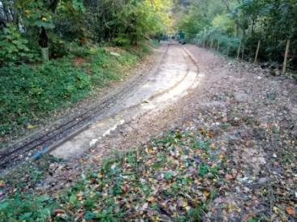
One side effect is the run will be longer, at 1.1 miles, with trains passing through the tunnel twice. Not only that, the railway operation can be split into two routes BC/GW/BC and GW/BE/GW giving the operations department a bit of headache,

plus fun and added interest for the rest of us.

Work started on the ground at the end of October school half-term holidays. A digger and powered barrow were hired-in and members spent the next 2 weeks moving countless tonnes of soil and clay sub-soil to open out the new station space. Materials were not exported from site, but relocated to help shore-up our embankments and other low-lying areas, with most being transported by train in wheelbarrows on modified carriage chassis - “barrowflats”.

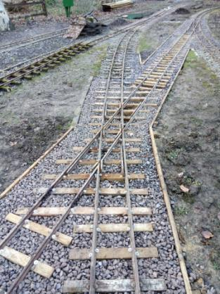
The existing points were returned to our workshops for servicing and re-sleepering, then relocated.

The opportunity is being taken to upgrade point motors from old wheelchair & car windscreen wiper powered versions to new machinery. A major revamp of the S&T installation has also been necessary, more of that later. Panels of plain track have been lifted & re-sleepered as needed for their new locations. All of the new alignments created have been made with side timber edging to contain the track formation. A layer of recycled road plainings was then covered with a geotextile membrane before limestone chippings were laid to support the sleepers.

As mentioned, the signalling system has also been subject to complete rework – some thought it may just be simple changes, but in reality it quickly became obvious that most of the relay cupboard needed to be rearranged. So far in excess of 50man hours has been spent just on the interlocking, with train detection and external equipment (signals and treadles etc) still to be done.
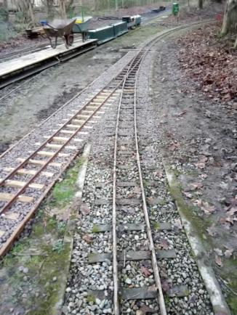
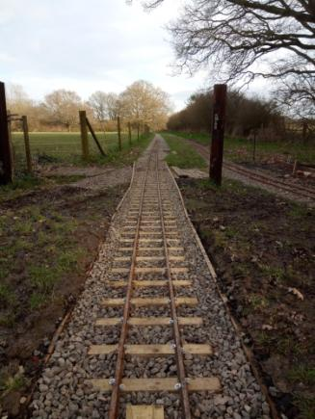
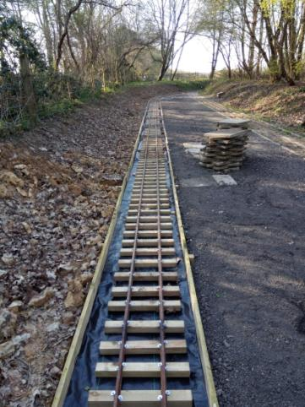
We had hoped to finish the track revamp in time for our Easter re-opening, with the revised signalling following shortly after, but the covid-19 pandemic and lockdown has paused the project for the time being.
The team are hoping to get back on site as soon as the restrictions are lifted, so that we can get the project finished in time to reopen to the public as soon as we are allowed, and it is safe for us all, to do so. Meanwhile, anything that can be completed at home in readiness, is being done.
Article and pictures by Kara Tombling

Eastleigh Lakeside Steam Railway
Sadly, owing to the present restrictions imposed because of the coronavirus, this short report is being written somewhat isolated from the railway.
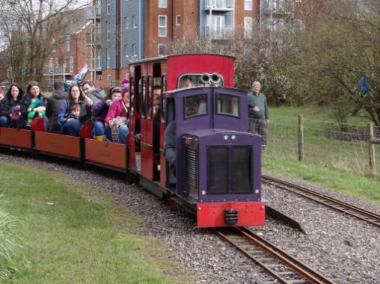
The year began with growing optimism that the year ahead would be another good one, with a full calendar of special events; then Covid 19 struck. Who would have thought that in the twenty first century, a virus could strike the whole world down in such a rapid manner? Anyway, before the instructions were issued to close, the railway was able to run its first Special Weekend, the Diesel Gala, at which friends both old and new, brought diesel locomotives to run on the mile and a quarter circuit. It was good to welcome visitors from the Welsh Highland Heritage Railway, Porthmadog who brought a fine collection of ‘Freelance’ 7¼˝ gauge industrial style locomotives, as well as friends from very much closer, for instance, Ropley Miniature Railway, who brought 10¼˝ gauge ‘Patricia’ an American outline engine that proved to be very popular with the younger generation. Other railways that brought locomotives included, in no particular order, Stapleford Miniature Railway, Hastings Miniature Railway and Hastings Alexandra Park, East Herts MR and Swanley New Barn; if I have missed anyone out, my apologies.
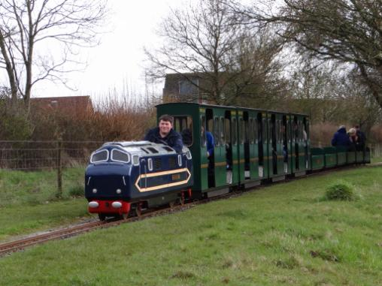
I think it was quite a coup to get Stapleford Miniature Railway to bring down ‘White Heron’ a 10¼˝ gauge Warship style diesel hydraulic built by Curwen and Newbury since I believe it was the first time that the locomotive had ventured beyond its Leicestershire borders.
Overall the weekend was a great success and that will, no doubt, be repeated in future years.
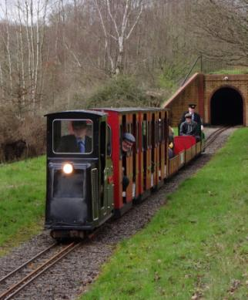
Of course, running a railway, as everyone realises, is not all about special events but also routine maintenance of track and rolling stock making sure it is safe to carry passengers. To this end, a number of sleepers have been replaced and major pieces of infrastructure work – the upgrading of the line across the ash-pit into platform 2 – have all been

completed before the shutdown.
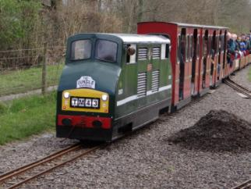
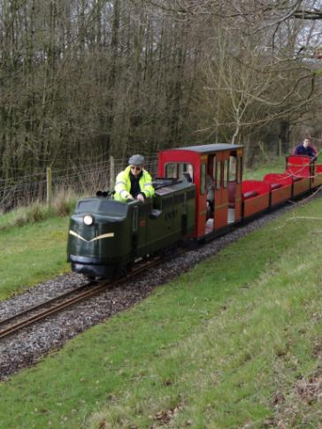
None of us knows when this period of social distancing will end but I hope it’s soon for no-one likes to see empty stations, idle engines and rolling stock and rusty rails. I wish everyone well.

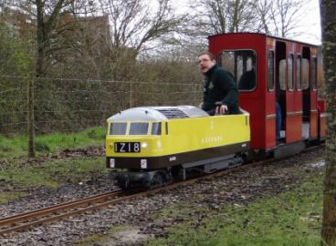

Lionel Kay.
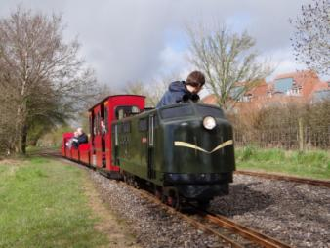
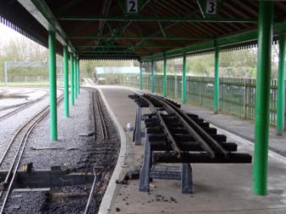
Photographs by Lionel Kay ‘Tegan’ from Swanley New Barn, returning to Parkway Station with a fully loaded train. 14th March 2020: Stapleford’s ‘White Heron’ heading along the top straight towards Monks Brook Halt. 14th March 2020: Ropley Miniature Railway’s ‘Patricia’ pulling away from the tunnel. 14th March 2020: Swanley New Barn’s ‘Kestrel’ travelling towards Monks Brook Halt. 14th March 2020: ‘Vanguard’ from Hastings Miniature Railway leaving Monks Brook Halt. 14th March 2020: Eastleigh Lakeside Railway’s ‘Eastleigh’ climbing away from the tunnel. 14th March 2020: Ropley Miniature Railway’s ‘Patricia’ returning to Parkway Station: The up grading of the track into Platform 2 17th March 2020
Thompson Park Miniature Railway

As 2019 was a very good year for the railway it was decided to close down until February to give our volunteers time to themselves. When we started back again in February several jobs were earmarked for completion before we reopened to the public on the first weekend in April. A thorough check of the one kilometre track identified several sleepers that needed replacing. With yellow spray paint in hand over 100 sleepers were marked.
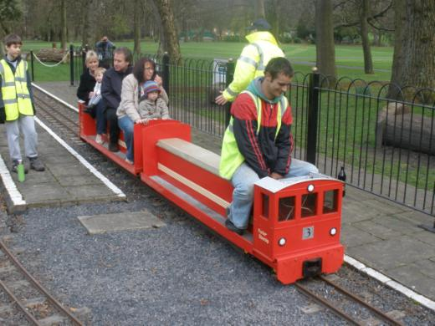
We have had an appeal out locally for more volunteers and three young people duly arrived wanting to help. They were all very willing to start work. After explaining how to do the job they set out with new sleepers, screws, washers and tools required. What a fantastic job they did over the next four weeks over 100 rotten sleepers were replaced with new ones.

Whilst this was going on our CME was replacing the hydrostats in two of our locomotives and making sure everything was ready to run when we did open to the public. All the coaching stock was cleaned and given the all clear for use. Every locomotive was given a clean bill of health apart from 'Black Jack' which needed quite a bit of work doing to it before it could go back into service and railcar which was undergoing a full refurb.

The station and bridge were the next two jobs to be attended to. The moss was to washed off and then both the full 100 metre bridge and the station railings were to be painted. The washing was done and work started on the station railings. We were also repainting the white lines around the turntable and the station.

Things were going so well then we were hit by Covid 19. The decision was taken on Monday 23rd March to suspend all further work and declare the railway closed until further notice. The site is visited when our local members go for their daily exercise and we know that the park rangers also keep an eye out for any problems. So far everything is okay and when things change we will be ready to run. The picture is of railcar before we started converting it into a three car class 150.

I have an addition to add to our story. I learnt that our President Fred Berry who was member No.2 and present at the first meeting of the Burnley and Pendle Miniature Railway Society at Nelson in 1990 sadly passed away on Saturday 4th April peacefully in his sleep at the Royal Blackburn hospital. Mike Bailey.

Brickworks Miniature Railway Update
Before the Corona virus struck we have been quite busy at the Brickworks’ Museum at Bursledon. Hampshire Narrow Gauge Trust finally officially left the site at the end of February and we had to send a considerable amount of time sort out the mess left behind, repairing damage, replacing points, clearing out “sheds” and trying to repair damage to Ashby (our 2 ft industrial engine). We have also been busy recruiting new volunteers, some ex members of HNGRT as well as interested locals.
Re the current 7 ¼ track, all the winter debris has been cleared, locos checked, carriages modified and got ready for the big Spring Steam up ( now cancelled) . The ticket office has been refurbished and there is a temporary cover for the current station.
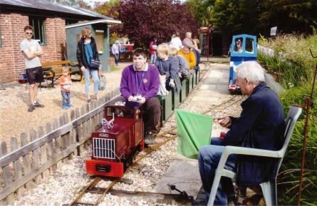
Re the planned new railway; we have started clearing obstacles from the proposed track route and fund raising (out of the £10,000 needed we have made a good start we have already raised £2000+), however additional donations always welcome! We had planned to get a JCB in for a week to clear the way for the new track and even got the steam group on site to use their dumper truck to help with spoil removal, but this has obviously all been put on hold. We also are still on the lookout for new/ second-hand track.
Here’s to a prompt return to “normal”.
Whitfield Light Railway
Following the Christmas branch line, the railway was rebuilt back down the field ahead of February half-term and in preparation for the usual seasons activities at The Hayloft, Cheshire. Event bookings were filling up the April-June period, and wedding bookings were also showing interest at The Hayloft.
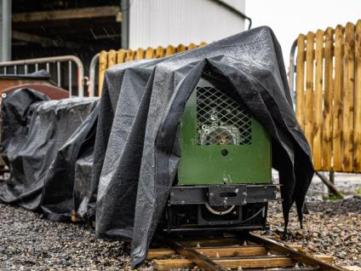
As for most of the UK, February was wet and stormy. When I could run the train it was with the small petrol-electric loco ‘Otter’, a coach and the tipper truck. This allowed me to do jobs through the day, while waiting for the infrequent passengers. The long-range forecast was showing an upturn in the weather around Mother’s Day weekend. It obviously didn’t show the other storm arriving.
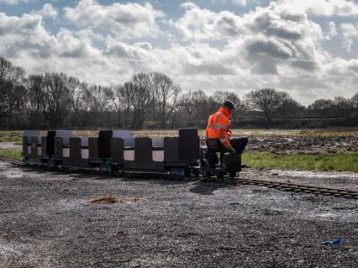
So March, as well as attempting to run the weekends, it was about recommissioning the artic coaches and the steam tram ‘Kestrel’. They hadn’t worked for a couple of months. She had some work done, where chain tensioners were added and the steam pipes lagged. The last weekend the railway ran was the 14-15th March. ‘Kestrel’ was in steam on the 18th, in preparation for Mother’s Day weekend. We never reached it, with the railway closing on the 20th and the cafe after the weekend.
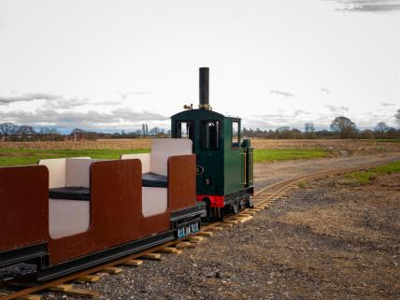
The railway is now locked away, safe and sound. As part of decommissioning, I removed parts of the railway so the farmer could carry on his business without having to work around the track. All events until the end of June are now pulled by the organisers, which is a crucial part of the year for the railway. So, I now await for the Coronavirus to pass, before I can understand the future plans for the railway, for my business, and my family. Take care and keep safe, Ian

Moors Valley Light Railway

We write this newsletter in the middle of what should be day 4 of the Easter Holidays, and the Sun hasn’t stopped shining! Along with everybody else the current situation surrounding COVID-19 means that we are not able to operate but as they say the show must go on, and it has.

Work continues in the workshops with a skeleton crew of 1 or 2 of us there, the beginning of this year has seen us make real progress on a couple of commission jobs. The first one being a complete rebuild of the bottom end of Sir Goss, a loco that has a great history with us at Moors Valley but as you know now lives at Swanley New Barn Railway.

The engine has been with us for some time but since the turn of the New Year we have made some great progress and things have started to take shape really nicely. The fact that the bottom end of Sir Goss was going to be completely new meant that we utilised this opportunity to complete technical drawings that can now be used for any 2-4-0 design, the drawings cover all aspects from the side frames to all parts of the valve gear.

The great news is that the effective kit of parts that arrived after being water cut went together extremely well and with relative ease. I have included some pictures of the build below.
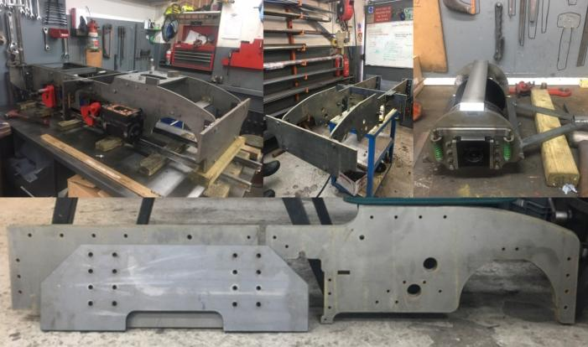

Whilst Sir Goss will be the first engine to benefit from this improved design it now enables us to start offering engine kits, these will be available to purchase in kit form or can be constructed as part of our engine building service that we offer as part of Narogauge Services. We have completed a similar task for the original Tinkerbell design.

If anybody would like more information or is interested please contact us at the railway. The work on Sir Goss is continuing with the next stage focusing on the new valve gear.

Our second job has seen us complete a re-tube, general bottom end overhaul and re-paint of Lord Randall from the Wayside Light Railway. The re-tube has been completed, successfully inspected by our boiler inspector and the engine has now been completely stripped down in readiness for its re-paint and overhaul of the bottom end. Some pictures of the work so far can be seen below.

The re-tube has been completed, successfully inspected by our boiler inspector and the engine has now been completely stripped down in readiness for its re-paint and overhaul of the bottom end. Some pictures of the work so far can be seen below.
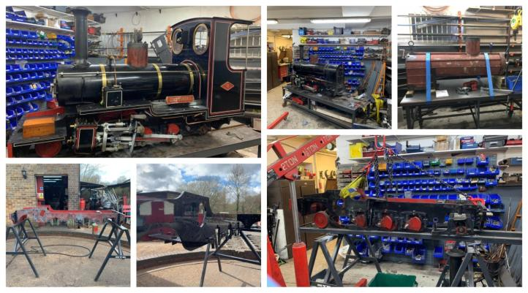
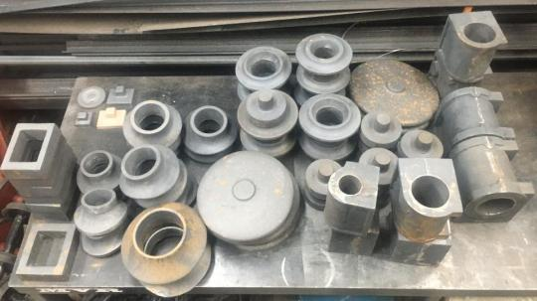
Before Christmas we picked up a number of castings that we keep in stock and that are available to purchase, these range from cylinder components to chimney caps and bases and also smoke box doors. These are suitable across a number of engines from the traditional Tinkerbell parts to some of the bigger components needed to build something like a Jason, our 2-4-4T.

This is a picture of the castings freshly back from the foundry. Again should anybody need anything like this please get in contact.

We will be utilising this time to do some of the jobs we wouldn’t normally have time to do. Fence replacement and other general maintenance jobs will ensure that we are ready and raring to go when we are able to open our doors again.

In the meantime we have decided to cancel all of our special events until September where we hope that we will be able to hold our annual Autumn Gala that is planned for the weekend of 12th & 13th September.
James

Informal Passenger Survey

Given the current circumstances this has been put on hold although the response to my request was poor. Only 12 railways out of a membership of some 45 replied which would have made generating any meaningful statistics very difficult.

We all hope that BGLR will resume normal service soon, in the meantime stay safe and well. Remember it used to be like this:

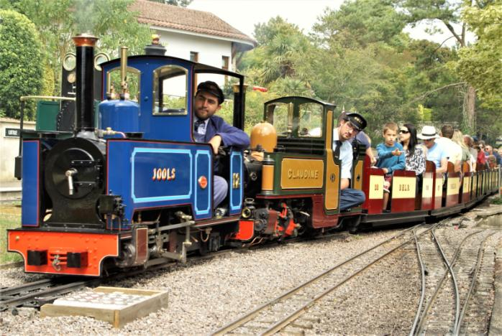

Newsletter prepared and circulated by
Tony Davies, Short Acres, Tiptoe Road, Wootton, New Milton, Hants, BH25 5SJ
Tel No – 01425 616622.
e-mail – dublorunner@gmail.com

All photographs are the copyright of the Railway featured in the article, unless stated otherwise.
BRITAIN’S GREAT LITTLE RAILWAYS Ltd Registered Office:- Moors Valley Railway, Moors Valley Country Park, Horton Road, Ashley Heath, RINGWOOD, Dorset BH24 2ET
Registered in England & Wales - Company No. 3143331
BGLR Website – www.bglr.org

