Moors Valley Railway
As we look back over 2019 it was overall a good year for the railway. Passenger numbers increased from 2018 by 12,000 helped mainly by the great start to the year. The first quarter of the year represented the best start to a year for 10 years, Good Friday being the busiest day of 2019.
We were also well supported at our special events by passenger numbers, we were lucky with the weather for pretty much all of them and this makes a big difference. We also made some tweaks to the events that we feel helped bring more people to the railway. For example combining the ‘Open Weekend’ with our ‘Model Railway Weekend’. Our Autumn Gala was blessed with glorious weather so we saw really high numbers of visitors for a September weekend.
The end of every year is always dominated by the preparation and the running of our Santa Specials, and 2019 was no different. We put on an extra day this year, meaning that we did 5 days in total and all were completely sold out by the end of October. We have already decided to increase the days to 6 for 2020.
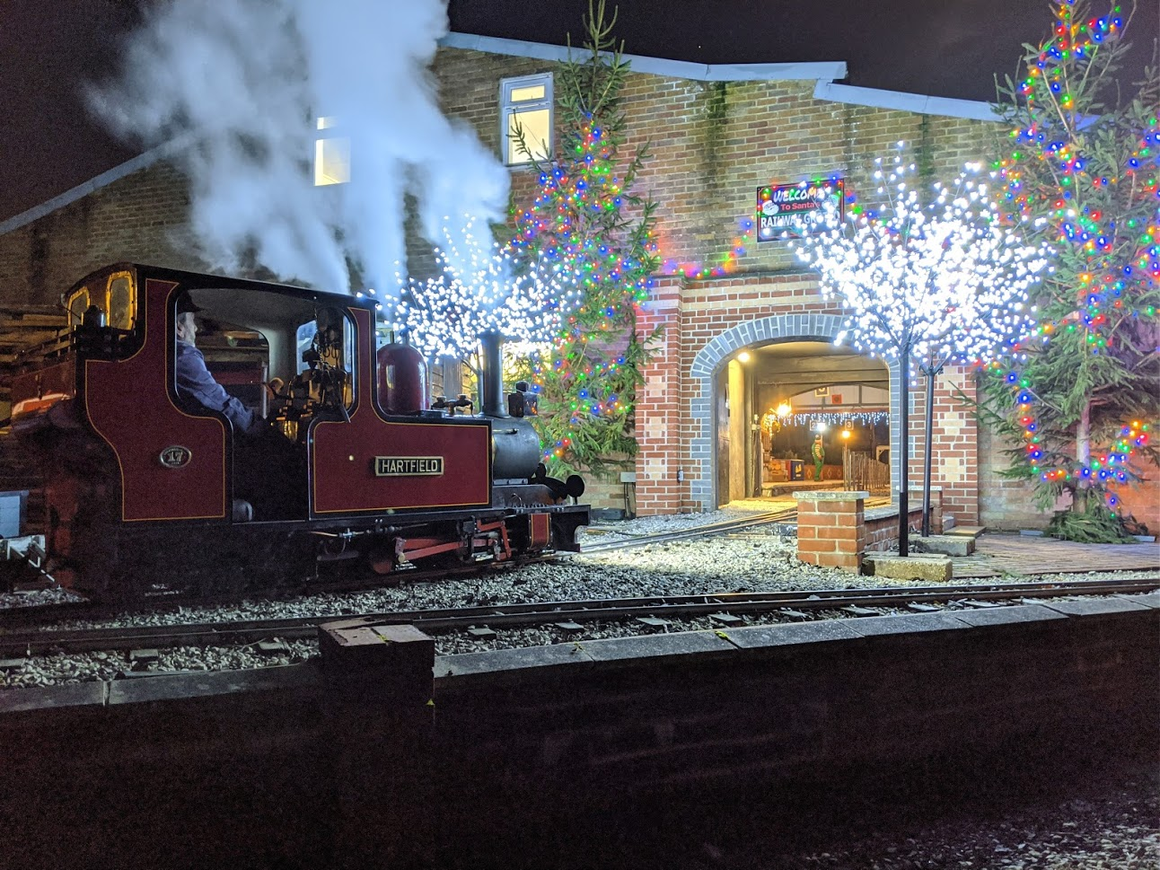
In addition to this we also held a very special ‘twilight’ Santa Special for a local group one evening in

December and this was well received by both the group and our volunteers alike. So much so that these are in consideration as bookable visits for 2020. We have included some pictures from the evening.
As we look forward to 2020 we have added a few more ‘family’ focused events for the year and we will also be commemorating the 75th Anniversary of VE day over the weekend of 8th, 9th, 10th May.
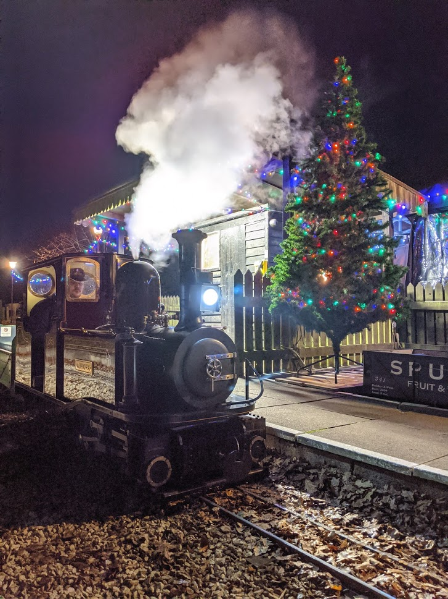
We have a number of projects that we would really like to make headway on this year, namely the overhaul of our garret locomotive “William Rufus” alongside some of our longer term development opportunities that we hope will get some traction in 2020.
Keep your eye out for our new website that we hope will be live in February, we can share more information regarding this when it is live.

